GasCarb

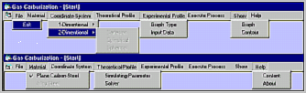
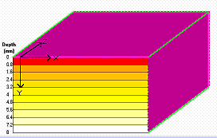

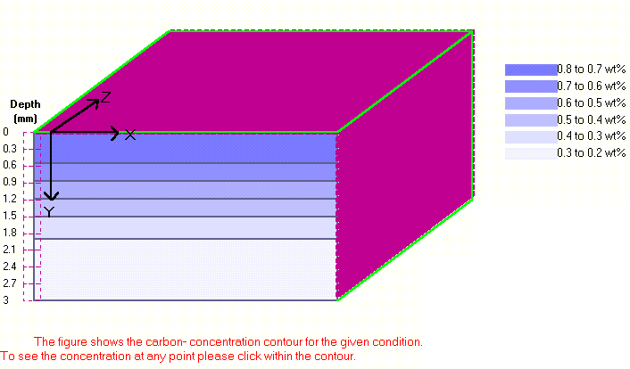

By

Simulation Group

What is GasCarb?

GasCarb is a mass transfer code used for simulating the one-dimensional gas carburising process for the plain carbon and alloy steels. It can be used in two ways: either to simulate and optimize the gas carburising process or to control the process on-line. The code uses finite volume techniques to solve numerically the diffusion equations.
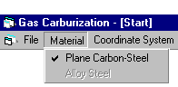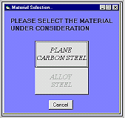

Applications

Prediction of mass transfer or carbon concentration in plain carbon and alloy steels.
It can be used for other heat
treatment process such as
nitriding with little modification.
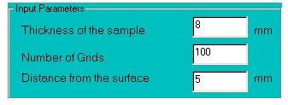

Modelling Features
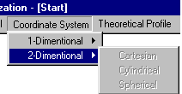
Automatic mesh generation internally.
One-dimensional solution for all coordinate systems i.e. Cartesian, Cylindrical and Spherical.
Transient solutions.
Can be used for various materials composition.
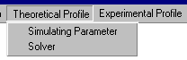Effect of various parameters on the process can be studied like concentration of carbon in the sample, carburising temperature, carbon potential of the furnace, etc.
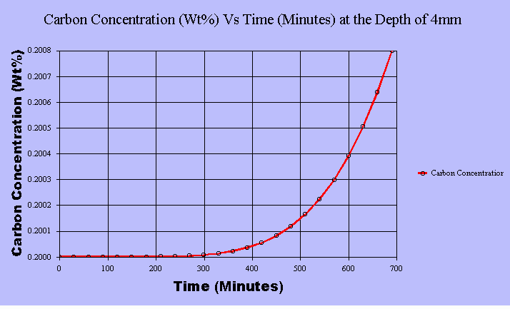

Numerical Features

Finite volume formulation which satisfies
the conservation of mass principle on each
control volume, has been used to discretise
the differential equations.
Implicit method has been
used for stable results.
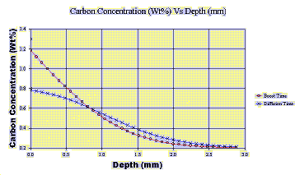TDMA has been used to solve the algebraic equations.

One-dimensional diffusion problem can be solved in any coordinate systems.
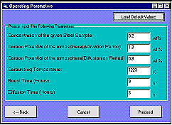Carburising sample has been made as mouse click event with advance software.

User Interface

Fully interactive menu-driven software.
Extremely user friendly.
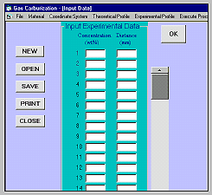Online context sensitive help.
Coloured plots of graphs and concentration contours.
Plot on user define points and parameters.
Experimental data can be given as input in various forms and they can be compared with theory on a same plot.
Allows importing tabulated data for comparison of the results.
All data can be loaded and saved.
Fully mouse driven, including mouse manipulation of the sample views.
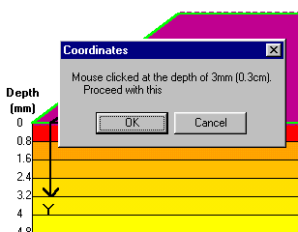Graphs can be saved and printed.

Main Features of the Software
The main advantage of GasCarb is that it can be applied directly to control the process online. Software has been designed in such a way that within few seconds it gives the results so that it can be used to correct the process online. The software predictions have been verified with industrial data which matches very well. In fact, the software is based on the important findings of many research papers which gives a cutting edge to it to predict more accurately. The Graphical User Interface of it is extremely user friendly.
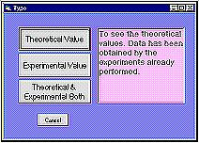

To Dear Managers (Heat Treatment)
Do you wish your carburizing process be Controlled by Case Depth and Carbon gradient rather than
just Temperature and CP?
Do you face Varying Case Depth with different carburizing batch?
Do you wish to Reduce Multiple Trial Runs for new component before production, which are costly
and time consuming?
Do you find it difficult to determine Optimum Boost and Diffusion Time to achieve hardness at
required case depth for good quality product?
Do you wish to Reduce Production Cost by Avoiding Costly Rework due to low hardness during
production?
Do you wish to Reduce Time of Process with superior product quality and carbon gradient?
Graphical Reports output for each process run with Carbon gradient from Surface to Case Depth?
To take control of above few challenges, GasCarb Design and Control solution can help you to

deliver better carburized products faster and gain competitive advantage.
GasCarb Design:
Simulate and study effects by change of variables like: Material, Initial Carbon in alloy, Carburizing
Temperature, Time and Carbon Potential in furnace.
Auto Boost and Diffusion time computation for superior carbon gradient and product quality.
Process cycle optimization for cost reduction and better component quality.
Support for multiple steel alloys for design and control.
Oxygen Probe mV auto correction based on CO Factor for accurate CP in furnace.
GasCarb Control: Displays Case Depth during production
Online control based on precise carbon concentration/hardness at required depth, irrespective of
variations in parameters like temperature and carbon potential during production run.
Consistent Case Depth for each batch processed.
Records furnace Temperature and Carbon Potential every 5 minutes and computes Carbon Gradient.
CO factor correction for accurate CP within furnace during the process.
Energy and gas utilization records for each batch.
Graphical Report of Carburization Job: Case Depth/Hardness, Carbon Gradient, Temperature and CP.
GasCarb Design and Control for:
Faster and Better Design – Without Compromise.
Solve your most challenging Case Harding Design Problems with Fast, Accurate and Flexible
Simulations.
Applies directly to online process to control carbon/hardness at required Case Depth.
Graphical Reports for each process run.

Contact:
Office Address:
Dr. Govind S Gupta, Professor
Department of Materials Eng
Indian Institute of Science (IISc)
CNR Road
Bangalore, KARNATAKA
INDIA
PIN - 560 012

Off: +91 80 23600472


Off: +91 80 22933240

Reach us at:
url: https://materials.iisc.ac.in/~govindg/

Mail to us:
e-mail: govindg@iisc.ac.in

